Approved Project Title
CareerPath AI – AI-Enhanced Career Guidance System for Personalized Career Pathways

Problem Statement
Many school and college students find it difficult to choose the right career path due to a lack of proper guidance about available streams, career domains, required skills, and future opportunities. Most students rely on general suggestions rather than personalized recommendations. CareerPath AI addresses this problem by providing career guidance based on the student's educational level, interests, favorite subjects, current skills, and career goals.

Project Objectives
- To provide personalized career guidance for school and college students.
- To recommend suitable academic streams for school students.
- To recommend career domains and job roles for college students.
- To identify missing skills required for a target career.
- To provide recommendations for technologies and certifications to improve career readiness.

Module List
User Authentication Module
Allows users to register and log in securely using their email and password.
School Guidance Module
Collects the student's interests and favorite subjects to recommend a suitable higher secondary stream.
College Guidance Module
Analyzes the student's skills and recommends an appropriate career domain, job role, technologies, and certifications.
Skill Gap Analysis Module
Compares the user's current skills with the required skills for a selected target role and identifies missing skills.

Use Case Diagram

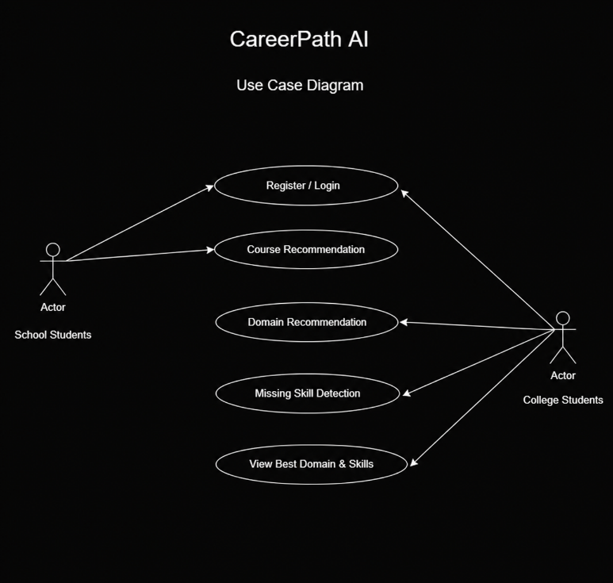

Table List
USER
- User_ID
- Name
- Email
- Password
- User_Type
SCHOOL_GUIDANCE
- School_Guidance_ID
- User_ID
- Interests
- Favorite_Subjects
- Recommended_Stream
SKILL_GAP
- Skill_Gap_ID
- User_ID
- Target_Role
- Current_Skills
- Missing_Skills
COLLEGE_GUIDANCE
- College_Guidance_ID
- User_ID
- Skills
- Technologies
- Certifications
- Recommended_Domain
- Recommended_Role

ER Diagram

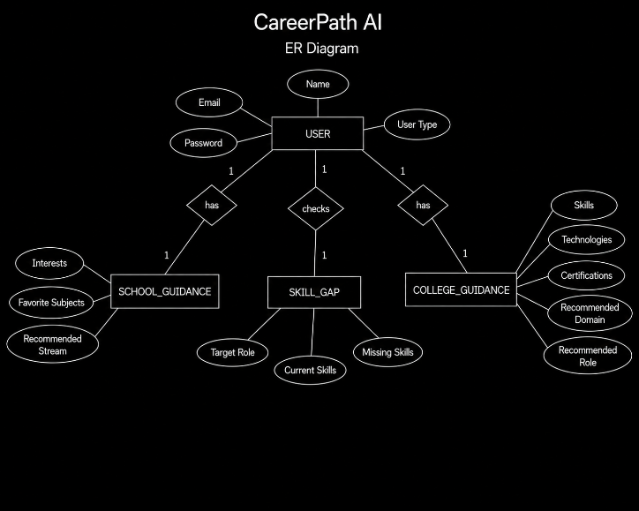

Page Layouts
The application contains the following pages:
- Home Page
- Login Page
- Registration Page
- Dashboard
- School Guidance Page
- College Guidance Page
- Skill Gap Analysis Page
The layout is designed to provide easy navigation between different career guidance modules.

UI Screens
The user interface includes:
- Login Screen
- Registration Screen
- Dashboard
- School Guidance Form
- College Guidance Form
- Skill Gap Analysis Form
- Recommendation Result Screen

UI Prototype
The prototype illustrates the navigation flow from user authentication to the dashboard and then to the School Guidance, College Guidance, and Skill Gap Analysis modules. Each module accepts user inputs and displays personalized recommendations.

Design Approval
The project design includes the overall system architecture, database design, user interface structure, and module workflow. The design was finalized before implementation to ensure consistency between the frontend and backend components.

Login Module
The login module authenticates users using their registered email and password. User credentials are validated through the backend API before granting access to the dashboard.

Registration Module
The registration module allows new users to create an account by providing their name, email, password, and user type. The entered information is stored securely in the MySQL database.

Dashboard UI
The dashboard serves as the central navigation page where users can access:
- School Guidance
- College Guidance
- Skill Gap Analysis
The dashboard also displays user information after successful login.

Forms Completed
The project includes the following forms:
- User Registration Form
- Login Form
- School Guidance Form
- College Guidance Form
- Skill Gap Analysis Form
Each form validates user input before submission.

Data Listing
The application displays personalized recommendations including:
- Recommended Stream
- Recommended Domain
- Recommended Role
- Suggested Technologies
- Suggested Certifications
- Missing Skills
The information is displayed in an organized and user-friendly format.

Frontend Review
The frontend was reviewed for:
- Responsive design
- Navigation flow
- Form validation
- User experience
- API integration
Necessary improvements were made before backend integration.

Backend Setup
The backend was developed using python flask. REST APIs were created to process user requests, interact with the MySQL database, and return recommendation results to the frontend.

Entity Classes
Entity classes were created for:
- User
- SchoolGuidance
- CollegeGuidance
- SkillGap

CRUD APIs
REST APIs were implemented for:
- User Registration
- User Login
- School Guidance
- College Guidance
- Skill Gap Analysis
These APIs handle Create, Read, Update, and Delete operations where required.

Login API
The Login API verifies user credentials stored in the database. Upon successful authentication, the user is redirected to the dashboard to access the guidance modules.

API Testing Report
All backend APIs were tested using Postman. The testing included:
- Request validation
- Response verification
- Database insertion
- Data retrieval
- Error handling
The APIs returned the expected responses for valid and invalid inputs.

Working Application
The React frontend, python flask backend, and SQL database were successfully integrated. Users can register, log in, access the career guidance modules, and receive personalized recommendations based on the information they provide.

Tested Project
The completed application was tested for functionality, user input validation, API communication, database operations, and navigation. All major modules worked as expected after bug fixes and validation.

Machine Learning Implementation

1. School Career Guidance Module
Machine Learning Used: Random Forest Classifier
This module uses a Random Forest Classifier to analyze the student's interests, favourite subjects, and preferred activities. Based on these inputs, the model predicts the most suitable academic stream, recommended course, and career path. The model was trained using a school career guidance dataset to provide personalized recommendations.

2. College Career Guidance Module
Machine Learning Used: Random Forest Classifier
This module uses a Random Forest Classifier to recommend suitable career domains and job roles. The model evaluates user inputs such as skills, technologies, certifications, and preferred work area to predict the most appropriate career path. The predictions are generated using a trained machine learning model built with career guidance data.

3. Skill Gap Analysis Module
Technique Used: Rule-Based Expert System
This module does not use a machine learning model. Instead, it uses a Rule-Based Expert System that compares the user's current skills with the predefined skills required for the selected job role. The system identifies missing skills and recommends the technologies and competencies that should be learned to achieve the target career.

4. Model Deployment
The trained Random Forest models are stored using Joblib and loaded by the Flask backend during application startup. The backend uses these models to generate real-time career recommendations based on user input without retraining the models.

